INDIAN SCHOOL AL WADI AL KABIR
PRE-MID TERM EXAM (2023-24)
Class: X Sub: ENGLISH Max Marks: 30
Date: 25.05.23 SET-1 Time: 1 hour

Instructions:
- All questions are compulsory.
- The question paper consists of three sections. Section A-Reading (05marks), Section B –Writing& Grammar (10 marks), Section C Literature (15 Marks)
- Write question numbers correctly.
- Attempt one section at a stretch and then move on to the next section.
- Use of correcting fluid (whitener) is prohibited. Note: This paper consists of 5 printed pages.

SECTION A: READING (5 marks)

1. Read the following passage carefully:
(1 x 5 = 5 marks)
1.Ghost nets aren’t supernatural, but they are legitimately scary. A ghost net is a fishing net that’s been lost or abandoned in the ocean. They are one particularly appalling part of the global ghost fishing problem, which includes fishing gear abandoned in the water. Any net or line left in the ocean can pose a threat to marine life. Just because a net is no longer used by fishers doesn’t mean it stops working. These nets continue to trap everything in their path, presenting a major problem for the health of our oceans and marine life.
2. Ghost nets entangle sea turtles, dolphins and porpoises, birds, sharks, seals and more, apart from catching fish. The nets keep animals from moving freely, cause injuries and keep mammals and birds from rising to the surface for air. Since hundreds of animals can be caught in a single net, this threat is monumental. The ghost nets harm coral reefs too—breaking corals, exposing them to disease and even blocking the reefs from needed sunlight.
3. Ghost nets are also a major contributor to the ocean plastics’ crisis. Most modern nets are made of nylon or other plastic compounds that can last for centuries. According to a 2018 study in Scientific Reports, ghost nets make up at least 46 percent of the Great Pacific Garbage Patch. Those abandoned fishing lines and nets that do breakdown never go away; they just become smaller pieces of plastic. Marine animals mistake this microplastic for food and eat it, which can harm internal organs, keep them from eating and expose them to toxic chemicals.
4. Exorcising ghost nets from our oceans will require commitment, cooperation and innovation. Many groups are working to remove ghost nets from the sea and are collaborating with local fishers and governments around the world to identify target areas and remove as many nets as possible. In 2015, a single World Wildlife Fund for Nature (WWF)-led mission in the Baltic Sea hauled up 268 tons of nets, ropes and other material.
5. To stop these nets from becoming ghosts in the first place, conservation organizations advocate for fishing gear that can be traced to its owner so anyone dumping nets can be fined and refundable deposits on nets to encourage returning or recycling rather than littering. Tools like sonar reflectors that can make ghost nets easier to find and working with small-scale fisheries to develop more sustainable fishing gear and practices are other suggestions. It is only by attacking this problem from all sides, together with conservation partners, fishers and supporters, can we banish ghost nets and protect our oceans.
Based on your understanding of the passage, answer the questions given below:

i. Complete the sentence by choosing an appropriate option.
Ghost nets have been named so because they ___________ .
a) cause much harm to the marine life.
b) are functional though not in use by fishers.
c) are not owned by anyone.
d) act as a snare for all animals in oceans.
ii. List two ways to stop the nets from becoming ghosts:
iii. Select the option that conveys the opposite of ‘negligible’, from words used in paragraph 2.
A. unimpressive B. monumental C. exposing D. threat
iv. The writer would agree with the given statements based on paragraph 3, EXCEPT:
A. Most ghost nets take a few years to completely disintegrate.
B. Ghost nets contribute to the Great Pacific Garbage Patch.
C. Most ghost nets provide nutrition to marine animals, upon disintegration.
D. Ghost nets can curtail freedom of marine animals.
v. Select the most suitable title for the above passage.
a) The Scary Side of Ghost Nets
b) Ghost Nets – A Result of Human Dominance
c) Ghost Nets – A Menace to Marine Life
d) Ways to Tackle the Problem of Ghost Nets

SECTION B: WRITING & GRAMMAR (10 marks)
2.A Look at the following poster denouncing dowry. Based on the picture and using your own ideas write a letter to the Editor of a national daily expressing your views on the evils of dowry and how this problem needs to be tackled. (5 marks)
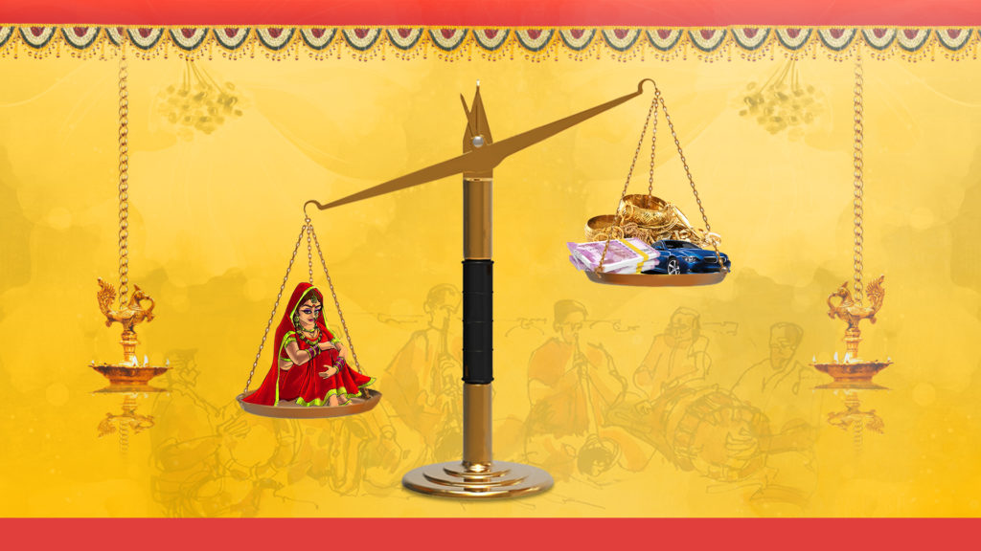

OR
2. B You are Rakesh/ Rita, a member of Animal Protection Forum of your state. You are working for the protection of animals from illegal killing and poaching. Using your own ideas, write a letter in about 100-120 words to the Editor of the Telegraph highlighting the above-mentioned issue to spread awareness amongst the public to control the problem.

3. Fill in each blank with the most appropriate option given below- (ANY FIVE) (1x5= 5marks)

i. The candidate __________________ speaking for ten minutes now.
a) had b) had been c) was been d) is being
ii. I ____________ white washing my house since morning, so I am feeling tired.
a) have been b) has been c) will be d) will have been
iii. This road _____________ to the post office.
a) leading b) leads c) has lead d) lead
iv. By next Monday he ______________ staying at my uncle’s house for three weeks.
a) will have b) shall have c) will have been d) shall have been
v. Yesterday, when I _____ home late at night, I _____ to find my house unlocked.
(a) had returned, was shocked (b) returned, was shocked
(c) was returned, got shocked (d) had to return, were shocked
vi. The regional competition awards have been announced and our school music club---------- the first prize.
a) had been won b) will win c) was winning d) has won

SECTION C: LITERATURE - (15 marks)
4. Attempt any ONE from (A) and (B) given below:
(A) Read the extract given below and answer the questions that follow: ( 1x4 = 4marks)
The way a crow
shook down on me
The dust of snow
From a hemlock tree
Has given my heart
A change of mood
And saved some part
Of a day I had rued.

(a) Choose the option that lists the possible feelings of the poet prior to the experience shared in the poem.
(i) reassured (ii) disappointed (iii) curious (iv) demotivated (v) thankful
(vi) disheartened (vii) impulsive
(a) 1,3 and 7 (b) 2,4 and 6 (c) 5 and 7 (d) 1 and 3
(b) In the poem, which negative symbols have been used to create a positive effect?
(i) hemlock tree- crow (ii) crow- snow (iii) snow- hemlock tree (iv) crow- dust
(c). Select the sentence in which the word ‘shook’ is used in the extract.
(i) They shook hands at the airport and parted their ways.
(ii) The accident shook his family to their core.
(iii) She shook the laundry before hanging it on the line.
(iv) He shook his head in shame when his name was called at the last.
d. Synecdoche is a poetic device that uses a part to represent the whole. Pick an example of synecdoche from the poem.

OR
(B) ) Read the extract given below and answer the questions that follow: ( 1x4 = 4marks)

The moment the letter fell into the mailbox the postmaster went to open it. It said: “God: Of the money that I asked for, only seventy pesos reached me. Send me the rest, since I need it very much. But don’t send it to me through the mail because the post office employees are a bunch of crooks. Lencho.”
- On reading the letter the postmaster was
- confused (ii) dismayed (iv) pleased (iv) puzzled

- ‘The post office employees are a bunch of crooks’ The statement is:
(i) thoughtful (ii) sad (c) laudable (d) ironic
- “…….. Bunch of crooks’ Pick the option that DOES NOT collate with ‘bunch of’ correctly.
(i) bunch of islands (ii) bunch of keys (iii) bunch of flowers (iv) bunch of grapes
- Why did Lencho not want the money to be sent through mail?

5. Answer any TWO of the following questions in about 30-40 words: - (3 x 2 = 6 marks)
- What is ironic about the post office staff helping Lencho?
- What do people think about the end of the world? Who does the poet side with and why?
- Why is Mrs. Pumphrey responsible for Tricki’s condition?

6. Answer any ONE of the following questions in about 100-120 words: - (1 x 5 = 5 marks)

- Mrs. Pumphrey, the overindulgent and caring mistress of Tricki, pampers her pet dog like a spoiled child. Comment.
OR
- Some moment proves to be very significant and saves rest of the day of poet from being wasted. Explain on the basis of the poem ‘Dust of snow’.

